Stor2rrd

Introduction
STOR2RRD is an open-source software tool that is used for monitoring and reporting performance in storage systems, SAN switches, and LAN switches. It is developed by the Czech company XoruX.

This is dockerized version of single XoruX application - STOR2RRD. It's based on the latest official Alpine Linux with all necessary dependencies installed.

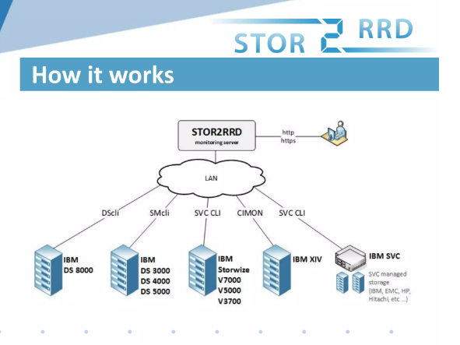

STOR2RRD will provide you a single web-based interface where you can view the performance of all different systems.STOR2RRD is one of the best tools offers you end-to-end views of your storage environment including LAN and SAN. It can save you significant money in operation monitoring and by predicting utilization bottlenecks in your virtualized environment.
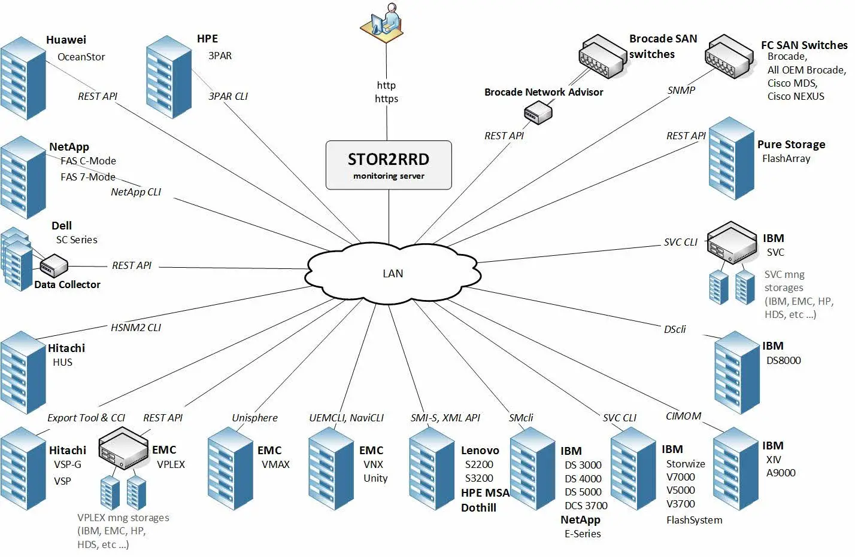

Also you can generate policy-based alerts, view the overall health status of your systems, provide capacity reports and forecasting data.

Free performance monitoring tool for storages with following features
Create storage utilization graphs for monitored storages
Create historical and nearly on-line utilization graphs

It graphically presents Iow rate, data throughout, response times
front end and back end data
Ports, pools, arrays, ranks, mdisks volumes drives
Host aggregated graphs

The full list of supported systems is significant and includes both storage systems and switches
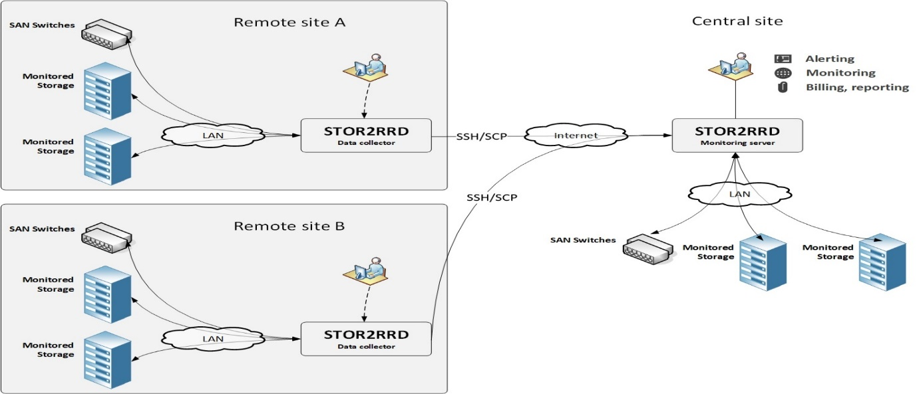

STOR2RRD is free software which you can redistribute it and/or modify it under the terms of the GNU General Public License. For customers, under support, there is distributed the enterprise edition with additional benefits

Website | https://stor2rrd.com/
Organization/Foundation Name | XoRux
License | GNU General public license
Open/Proprietary | Open
Source Path(if open source) | https://github.com/Silvanus19/stor2rrd.git
Brief Description | Stor2rrd is a free Storage, SAN, LAN Performance and Capacity Monitoring Tool. Analyze key infrastructure performance metrics of your Storage, SAN and LAN devices. Prognosis for all your Infrastructure. Monitor and troubleshoot pro-actively. Optimize your mission-critical IT infrastructure.

Project Summary

Project Details

Key Features
Real-time storage, SAN and LAN performance visibility in multi-vendor environment

Historical reporting (graph, CSV, PDF, XLS)

Alerting based on performance thresholds

Event monitoring

You can find utilization of any attached storage in a simple graphical form comprehensible to anyone from technician to management level

Free to use. You do not need to purchase expensive commercial solutions

Optional Paid support

Simple administration

Enterprise edition

STOR2RRD will provide you a single web-based interface where you can view the performance of all different systems. STOR2RRD is one of the best tools offers you end-to-end views of your storage environment

It can save you significant money in operation monitoring and by predicting utilization bottlenecks in your virtualized environment.
STOR2RRD is free software which you can redistribute it and/or modify it under the terms of the GNU General Public License

We are building a new generation of our infrastructure-monitoring software based on Microservice architecture, TimescaleDB React and others.

Architecture
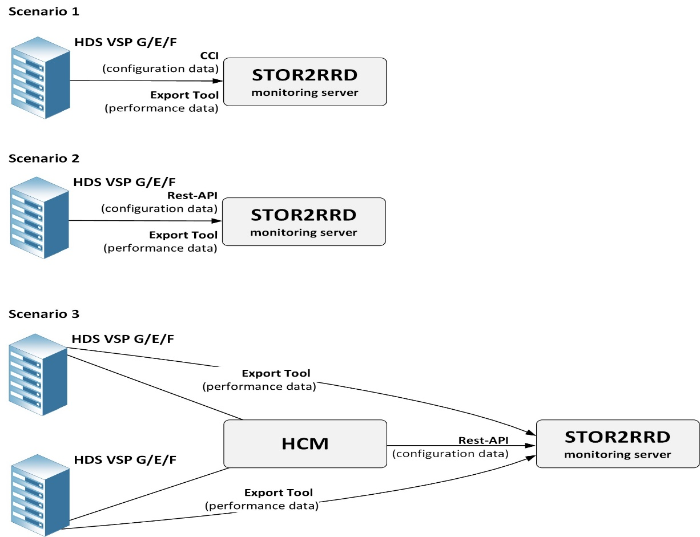

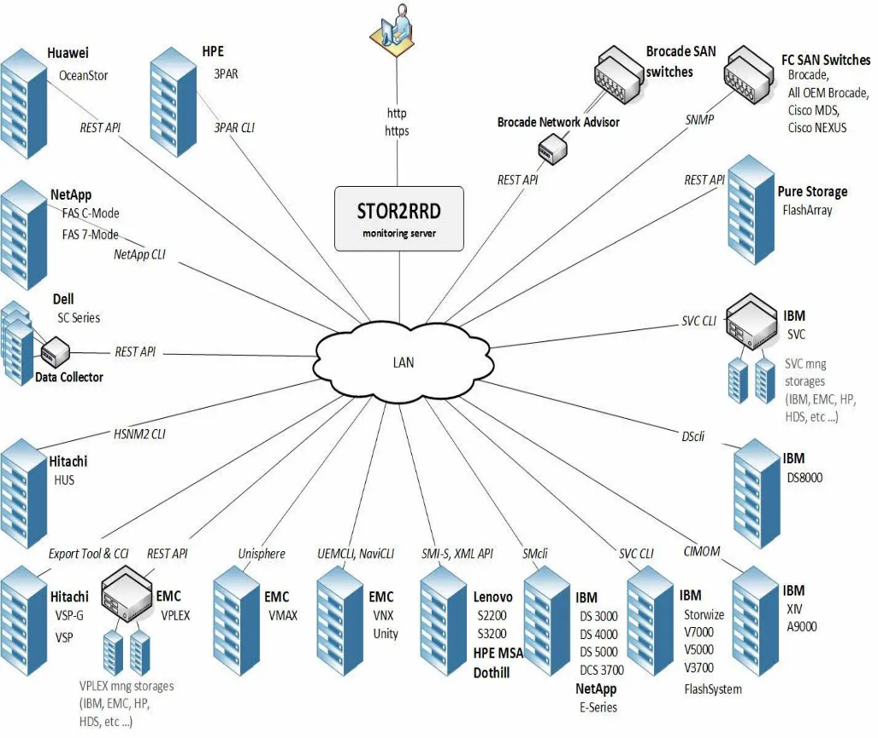
Stor2rrd is an open-source monitoring and reporting tool for SAN and LAN devices. It supports most vendors products such as EMC, Brocade, HPE and others.

The full list of supported systems is significant and includes both storage systems and switches

Current Usage
STOR2RRD is an open-source software tool that is used for monitoring and reporting performance in storage systems, SAN switches, and LAN switches. It is developed by the Czech company XoruX.

The software is compatible with various systems by Dell, EMC, Hitachi, HPE, IBM, NetApp, Synology, and others. It is also integrated with various storage systems, including Tatlin, Unified.

The software is being used by organizations and products in various industries and brands such as

IBM, NetApp, EMC^2, Fujitsu, Infinidat, Huawei, Hitachi, VM ware, Microsoft partner, red hat.

It offers value added resellers program is open for partners who want to be more agile partners who want to address new potential business.

Partners who want to get better knowledge of environment of their customers
Partners who need to monitor customers environment remotely
The value added resellers program is opened for partners who want to be more agile
Some popular resellers are

Converge one
Champion
Fortra
Duosis
Corus360

Intendo
Netria
Softine
Syssoft
Impromat

Technical Details

Performance part have 3 predefined time ranges (last day/week/month) with crucial metrics IOPS / Data throughput / Latency

STOR2RRD monitors IO and data throughput of all volumes and creates graphs per volume and aggregated with all volumes. In order to make aggregated graphs easy readable it comes with its own approach how to place all volumes into single aggregated graph.

Capacity is reported per pool
Real-time storage and SAN performance visibility in multi-vendor environment Historical reporting (graph, CSV, PDF, XLS) Alerting based on performance thresholds Event monitoring
Optional monitoring
It is intended as a front end tool for admins
Quick search of actual and historical utilization
Searching of unusual behavior
Alerting

Historical Reporting
To see trends based on historical data
Create reports for other teams and management

Project comparison

LPAR2RRD is an open-source software tool that is used for monitoring and reporting performance of servers, clouds and databases. It is developed by the Czech company XoruX

Microsoft Storage Spaces Direct (S2D) monitoring This is monitored by our sister product called LPAR2RRD as part of its Microsoft HyperV cluster monitoring.

LPAR2RRD is an Open Source software
LPAR2RRD is published as an open source software under the General Public License version 3

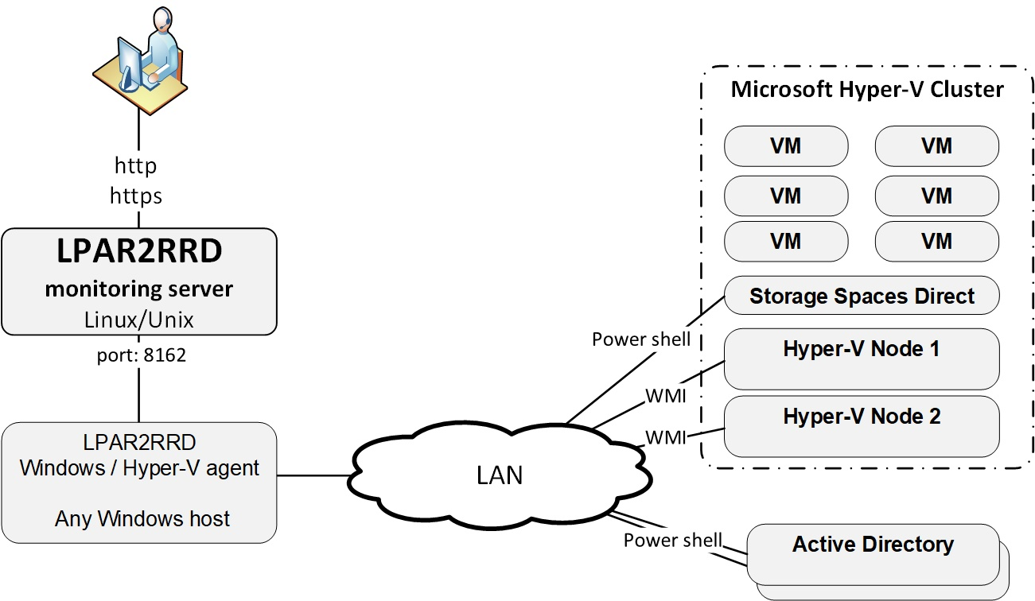

The software tool is designed to monitor and report on server virtualization utilizations. It produces utilization graphs, reports, or alerts of physical or virtual servers on CPU, memory, IOPS, and many other depending on specific virtualization platform.

It also supports database engines as Oracle Database, PostgreSQL or containerization platforms like OpenShift or Docker. Cloud technologies are supported as well.

The software is compatible with various systems by IBM Power Systems, IBM , VMware, Nutanix, Oracle VM, Oracle Solaris, oVirt / Red Hat Virtualization, XenServer, Microsoft Hyper-V, Linux, Oracle Database, PostgreSQL Database, Microsoft SQL Server, Amazon Web Services, Microsoft Azure, Google Cloud, Apache CloudStack, Kubernetes, Red Hat OpenShift, Docker, Huawei FusionCompute, and Proxmox.

Any other information

The tool offers you end-to-end views of your storage environment including NAS and SAN and can save you significant money in operation monitoring and by predicting utilization bottlenecks in your virtualized environment.
You can also generate policy-based alerts, view overall health status of your systems, provide capacity reports and forecasting data.

Analyze key infrastructure performance metrics of your Storage, SAN and LAN devices.
Prognosis for all your Infrastructure.
Monitor and troubleshoot pro-actively.
Optimize your mission-critical IT infrastructure.

Reference / Acknowledgements
https://stor2rrd.com/
https://lpar2rrd.com/

-----------------------------End of the template--------------------------------

